IDEONE para c++

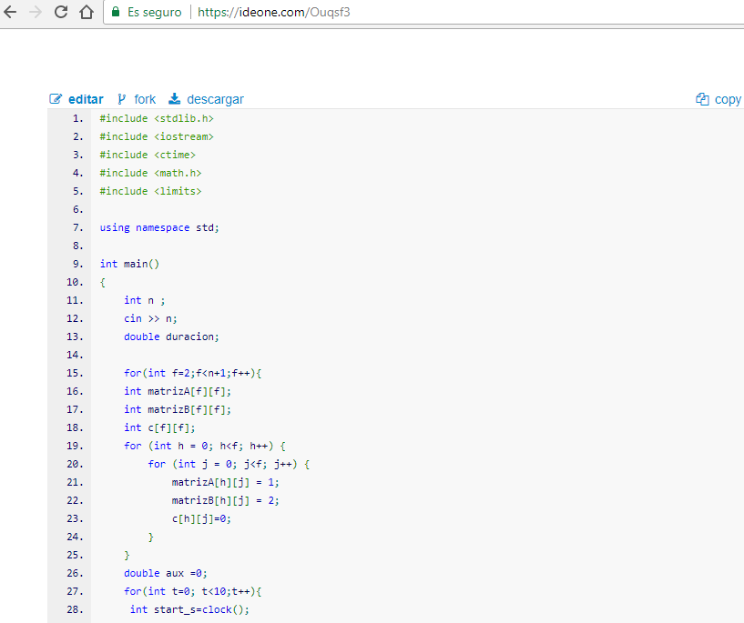

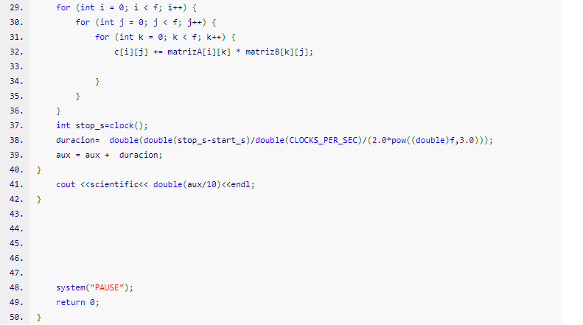

OUTPUT

2.500000e-08

9.259259e-09

2.343750e-09

1.200000e-09

1.157407e-09

1.020408e-09

8.789063e-10

8.916324e-10

8.000000e-10

8.264463e-10

6.944444e-10

7.282658e-10

7.470845e-10

7.259259e-10

7.080078e-10

7.123957e-10

7.201646e-10

7.071002e-10

6.937500e-10

6.910701e-10

8.358377e-10

7.068299e-10

6.618924e-10

6.560000e-10

6.486117e-10

6.553879e-10

6.536990e-10

7.462381e-10

7.351852e-10

6.545601e-10

6.591797e-10

6.998358e-10

7.149400e-10

7.405248e-10

7.544582e-10

6.495173e-10

7.799971e-10

7.923262e-10

7.460937e-10

7.486833e-10

7.545082e-10

7.659703e-10

7.084664e-10

7.083676e-10

7.222405e-10

7.011934e-10

6.953487e-10

7.008134e-10

6.972000e-10

6.905338e-10

6.770596e-10

6.653143e-10

6.588808e-10

6.584523e-10

6.622403e-10

6.458127e-10

6.445016e-10

6.329761e-10

6.379630e-10

6.247219e-10

6.065171e-10

6.034865e-10

6.210327e-10

6.008193e-10

5.838342e-10

5.762012e-10

5.780264e-10

5.601064e-10

5.625364e-10

5.587981e-10

5.429366e-10

5.353236e-10

5.383442e-10

5.210074e-10

5.213269e-10

5.163920e-10

5.059509e-10

5.007717e-10

4.907227e-10

4.899885e-10

4.803507e-10

4.714168e-10

4.692055e-10

4.563403e-10

4.563277e-10

4.427467e-10

4.507889e-10

4.272528e-10

4.243484e-10

4.265026e-10

4.242392e-10

4.495516e-10

4.231962e-10

4.288672e-10

4.243074e-10

4.258919e-10

4.266398e-10

4.269303e-10

4.234500e-10